AUTH-020
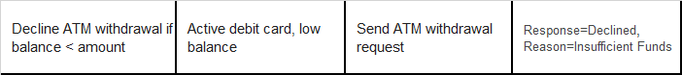
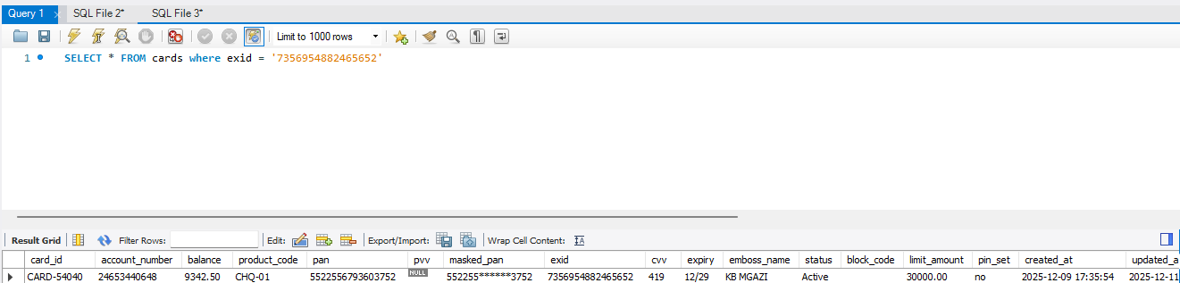
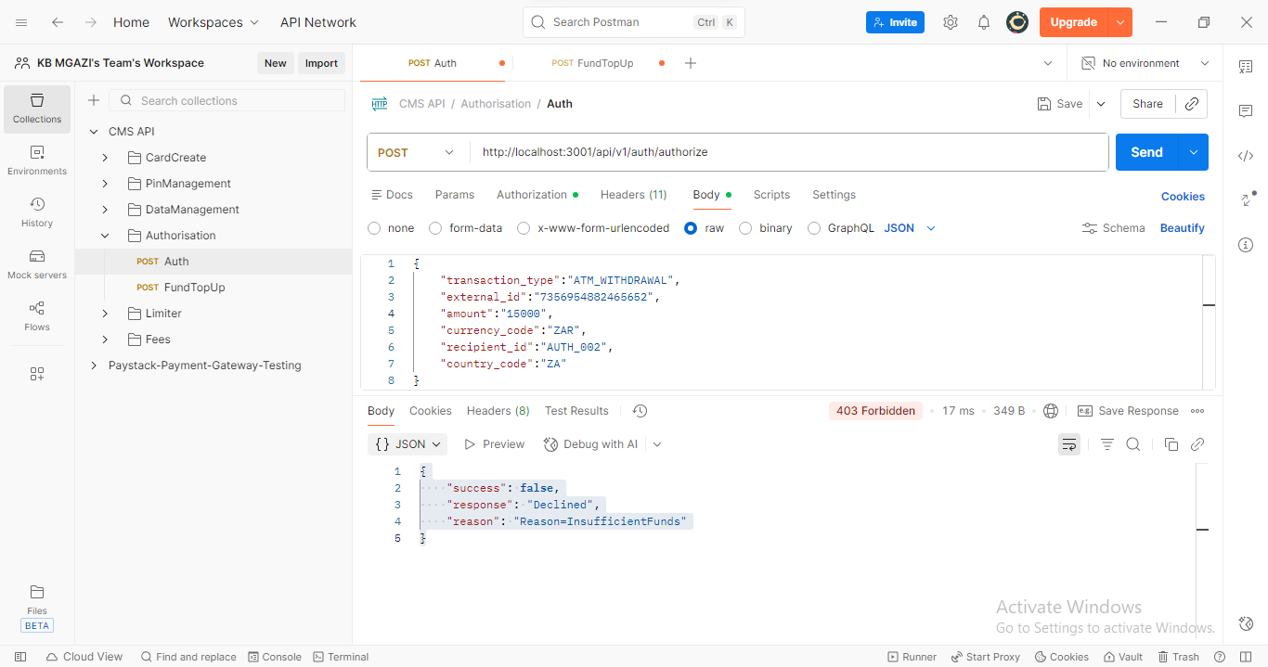
Request:
{
"transaction_type":"ATM_WITHDRAWAL",
"external_id":"7356954882465652",
"amount":"15000",
"currency_code":"ZAR",
"recipient_id":"AUTH_002",
"country_code":"ZA"
}
Response:
{
"success": false,
"response": "Declined",
"reason": "Reason=InsufficientFunds"
}

